**Amanda Mxi 13 April 2021**

**LEVEL 2 (Medium)**

**Sudoku Challenge**

**Pseudo code:**

1. Here you are using a 9by 9 grid, containing a square called a cell.
2. It has 9 columns 9 in a row and columns.
3. It has a block / region which is a 3 by 3 grid (subgrids) that contains 3 columns and 3 rows.
4. We have 3 sets of horizontal blocks, called a rank (top, middle, and bottom).
5. It has 81 cells in total.
6. Fill in the 9*9 grid so that each column, each row and each boxes (3*3 subgrids) contain the digit from 1 to 9 without no repetition.
7. The most basic strategy to find the missing numbers is scanning and it consists of
8. Cross-hatching
9. Counting
10. **Cross-hatching-** is when you scan rows and columns to eliminate where the specific number can be in a given region.
11. **Counting-** You simply count all the different numbers that is in a row, column that connect to one cell.
12. If there is one number missing, then that’s what should be in the cell.

**BONUS**

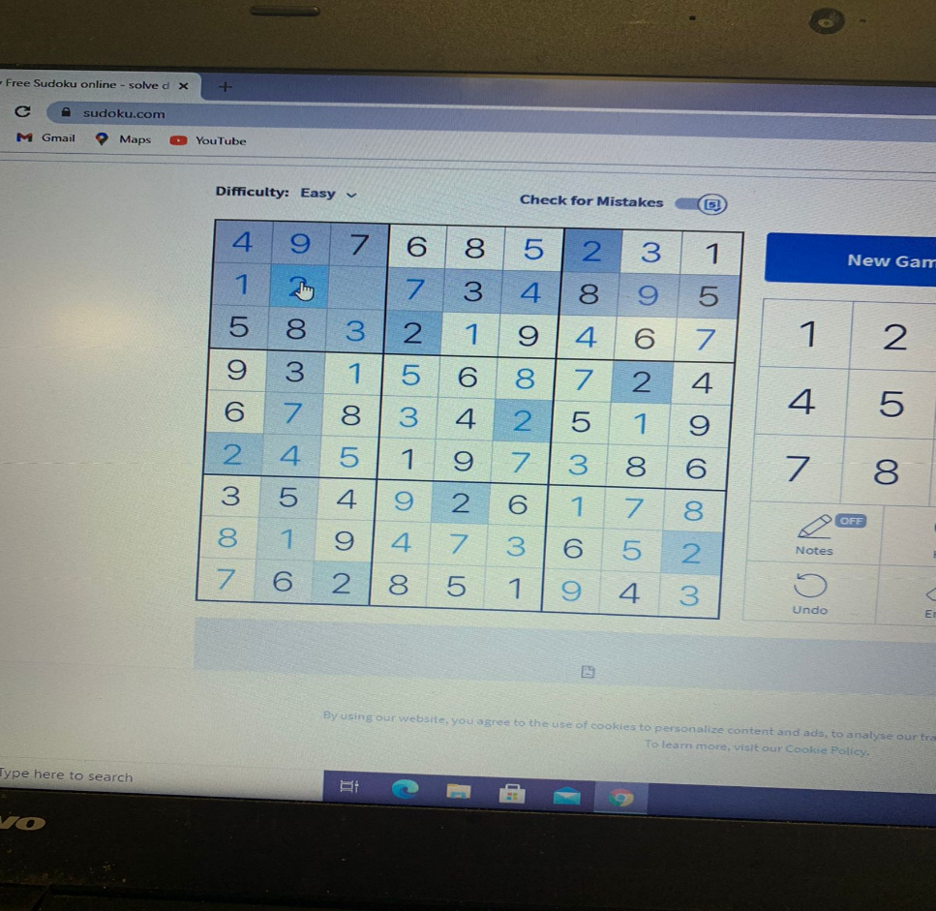

**LEVEL 3 (HARD)**

